- \Operation\Discharging\Downstream machine
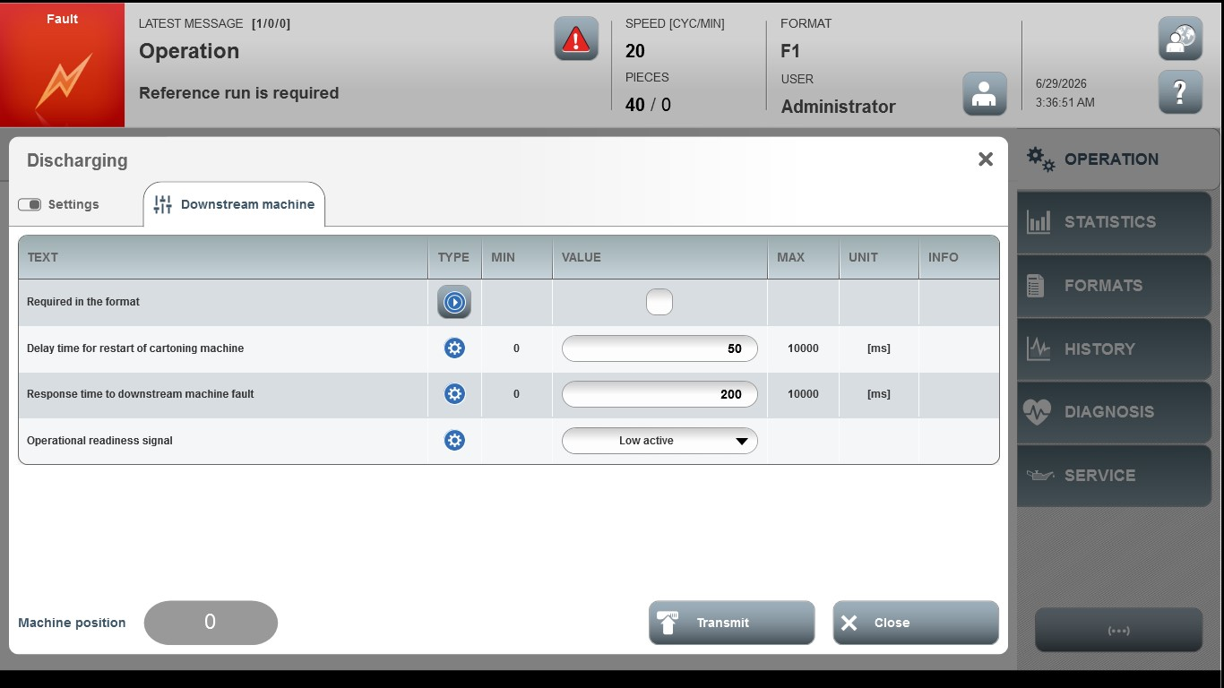
Acceptance criterion | Limits | Pass / Fail: Dev-No. | Date | Initials
Screen matches screenshot | N / A
Delay time for restart of  cartoning machine | 0 … 10000
Response time to downstream machine fault | 0 … 10000

